LAB 2

Murtaza ali qazi(2112120)&

Sabih Ul Hassan(2112126)

DEVOPS

Szabist Karachi

Task1

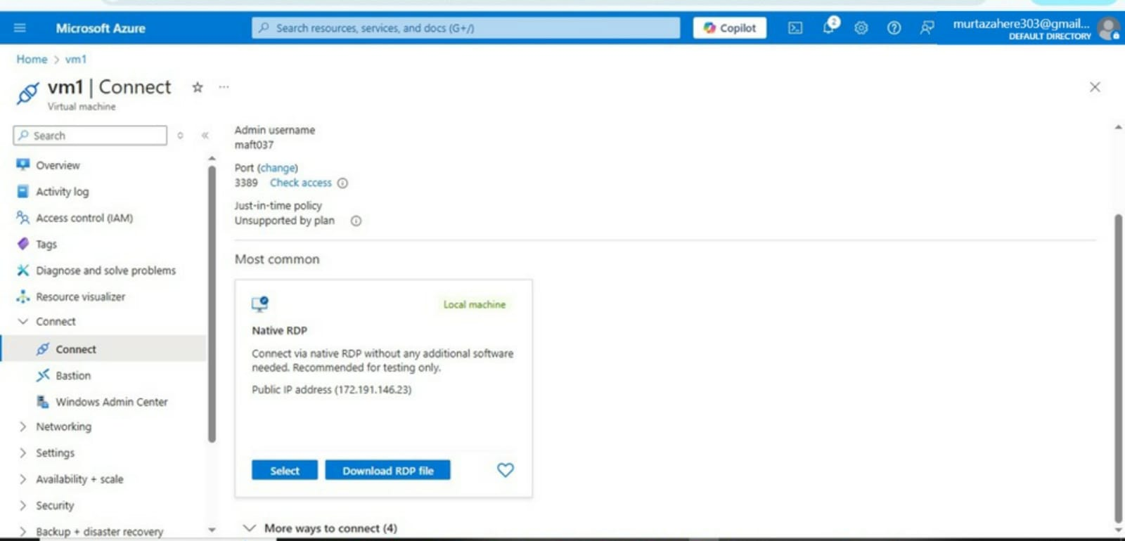

Task2

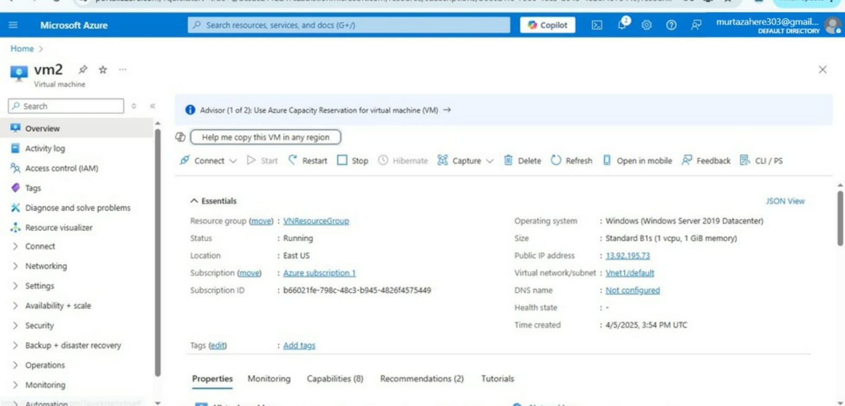

Task3

